Create new platformio-project
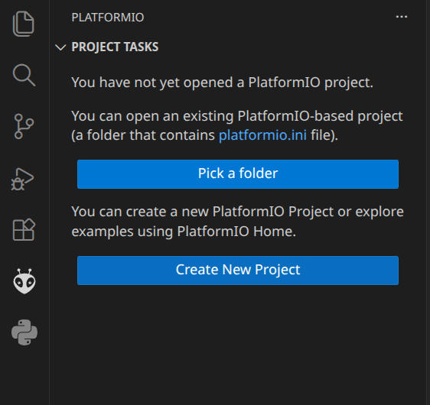

Install platform
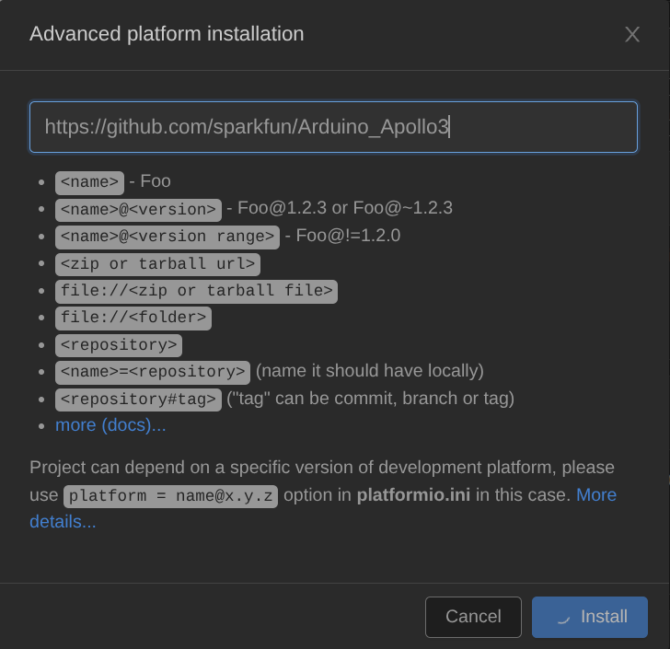

Denne funka ikke spesielt godt, eller, den tok ihvertfall lang tid
Install platformio – apollo3
~/.platformio/packages$ git clone --recurse-submodules --branch v2.1.0 https://github.com/sparkfun/
Arduino_Apollo3.git framework-arduinoapollo3@2.1.0

if@fedora:~/master/imu_test$ pio
bash: pio: command not found...
Install package 'platformio' to provide command 'pio'? [N/y] y

Following instructions from
https://github.com/nigelb/platform-apollo3blue
$ pio platform install git+https://github.com/nigelb/platform-apollo3blue

Kjører denne I prosjektmappe
pio init -b SparkFun_RedBoard_Artemis_ATP -O"platform_packages=framework-arduinoapollo3@https://github.com/sparkfun/Arduino_Apollo3#v2.2.0"

Install package 'tio' to provide command 'tio'? [N/y]

